How to select a cell with keyboard

In Excel, using keyboard shortcuts to move around the spreadsheet can save time, especially when dealing with a large number of rows and columns. By selecting cells with the keyboard, you can quickly move to specific areas of the data without the need to scroll or use the mouse.

This dataset represents a fictional employee database with 30 entries. Each entry contains information about an employee, including their ID, name, age, gender, email, phone number, address, city, state, country, occupation, salary, start date, department, manager, and employee status. The dataset covers various occupations such as Software, Sales, Marketing, Finance, Human Resources, IT, and Operations. The employees' salaries range from $50,000 to $80,000. The dataset also provides details about the employees' start dates, department assignments, and their respective managers. All employees in the dataset are currently active. Hence, it is a vey large dataset and we will learn in today’s tutorial how to navigate through sheet by using keyboard only.

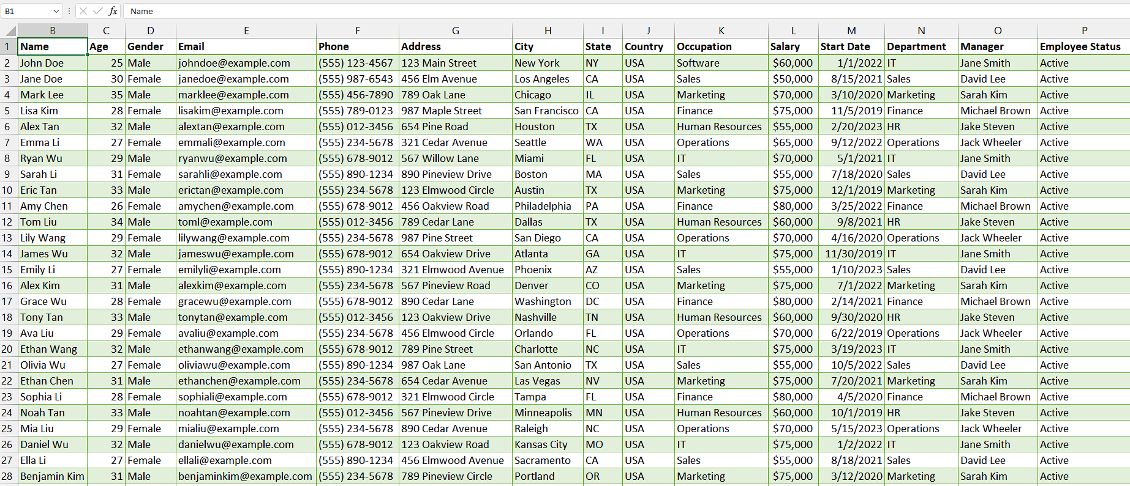

## Case 1 – Selecting single cell with keyboard

## Step 1 – Access the "Go To" dialogue box

* As mentioned that we will only use keyboard to navigate so, press Alt button on your keyboard.
* Then, small letters would appear on your Ribbon.
* Now, press the “H key” on your keyboard to open “Home tab”.
* After that, press “F key” and then “D key”.
* Now, press the “G key” on your keyboard.
* The “Go To Dialogue” box will appear on your screen.
* You can alternatively use F5 key or “Ctrl+G” to open it.



## Step 2 – Select the Destination cell

* In the "Go To" dialogue box, you will see a text input field labeled "Reference."
* This is where you can enter the destination cell. For example, cell “F20”.
* Then, press Enter and you’ll move to desired cell.



## Case 2 – Selecting range of cells with keyboard

## Step 1 – Access the "Go To" dialogue box

* Begin by pressing the Alt button on your keyboard, which will reveal small letters on your Ribbon.
* Next, use the "H key" to access the "Home tab."
* Once in the "Home tab," press the "F key" followed by the "D key."
* Proceed by pressing the "G key" on your keyboard.
* This action will prompt the appearance of the "Go To Dialogue" box on your screen.
* Alternatively, you can use the F5 key or the "Ctrl+G" shortcut to open the "Go To Dialogue" box.

## Step 2 – Select the Destination Range

* In the "Go To" dialogue box, you will see a text input field labeled "Reference."
* This is where you can enter the destination range.
* If you want to navigate to a range of cells, enter the starting cell reference followed by a colon (:) and the ending cell reference.
* For example, to go to the range A1:B10, enter "A1:B10" in the "Reference" field.
* Then, press Enter and your range will be selected.

